cRITERIA
Applicants must:
- Be ethnic minority students.
- Have proven academic success.
- Possess leadership skills.
- Be involved in the community.
- Participate in extracurricular activities.
- Have a strong interest in broadcasting, web journalism, public relations, journalism, social media or a related field.
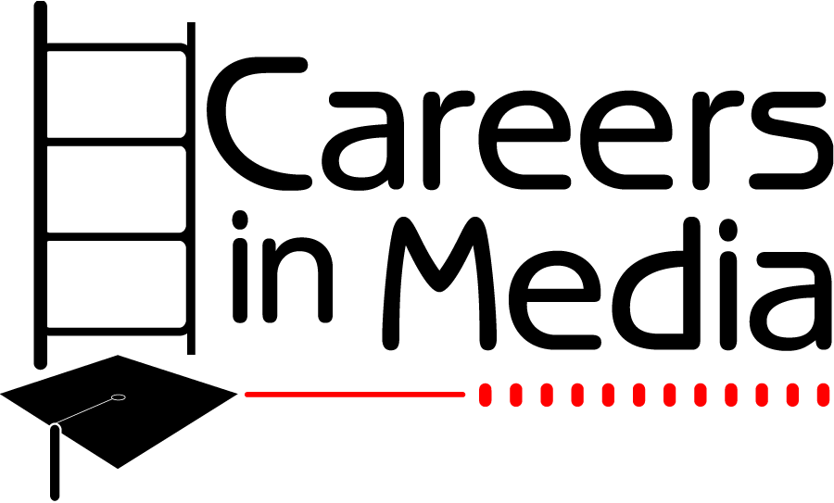
- Be high school juniors at the time of application.

APPLICATION
To receive an application, call 513-852-4015 or email mmorrow@wcpo.com. Please include with the application form:
- A letter of recommendation
- A copy of transcripts/latest report card
- An essay: “Why I want to explore the media field”
- Typed on 8 ½ by 11 paper
- 1-inch margins
- No more than 500 words

4. DEADLINE: MARCH 31.

Careers in Media
c/o WCPO-TV
1720 Gilbert Ave.
Cincinnati, Ohio 45202
WCPO.com

Phone (513) 852-4015
Fax (513) 852-4978
E-mail: mmorrow@wcpo.com


and its partners.

An Internship Program for Minority High School Students in the Greater Cincinnati Area

A community service of

cAREERS IN MEDIA
Careers in Media (CIM) is an internship program designed to provide hands-on experience to minority high school students with an interest in the media industry.
CIM PURPOSE
- To develop a talented pool of qualified minority individuals from which the media industry may recruit.
- To promote the various careers in the media industry.
- To provide leadership development and soft skills training to all participants.
- To give minority high school students an opportunity to learn about media from experienced industry professionals.
FOUNDING ORGANIZATIONS
- WCPO 9 On Your Side
- The Citizens’ Committee on Youth (CCY)
- INROADS, Inc.
.
RECRUITMENT
Eligible high school juniors are recruited through schools, community organizations and social media.
INTERNSHIP FORMAT
CIM is an unpaid high school internship program that begins the summer after a student’s junior year. Students participate for one summer, interning an average of 10 hours per week, for a minimum of four weeks between the first week in June and the last week in July. They explore areas of interest including, television, social media, print and public relations.
Interns also complete a project and present it at the end of the summer.
CIM interns are encouraged to participate in a four-day workshop at Ohio University at no cost to them.

PROFESSIONAL TRAINING
Interns have an opportunity to talk to industry professionals, participate in leadership development and hone their soft skills throughout the summer. Attendance is required. Course content includes:
- Writing
- Interviewing skills
- Dressing for success
- Business etiquette
- Public Speaking
- Communications skills
- College planning

